CHAPTER – 1

Introduction

One of the most vital parts of computers and programming is algorithms. Algorithms can be used/followed by programmers for consistency in problem solving. There are various types of sorting algorithms with their distinct implementations and strategies. But it can be quite hard to comprehend these algorithms. The main goal of the project is to create a program which would serve as a tool for understanding how the most known sorting algorithms work.

The algorithm that are used in the proposed system to visualize are Bubble sort, Quick sort, Insertion sort, Selection sort, Merge sort. Sorting visualizer will be built using Html, CSS and JavaScript. Html and CSS will be used to create the frontend. JavaScript will be used to provide functionality. Depending on the user choice, the data will be run on the corresponding sorting algorithm.

1.1 Motivation

The project required us to use web programming and we were taught various sorting algorithms in class. But we had never applied it anywhere other than our lab programs. Hence we decided combine sorting algorithms with web programming and visualize certain sorting algorithms for a better and clear understanding of their working.

1.2 Problem Statement:

To create a web application using HTML, CSS and JavaScript that visualizes sorting algorithms and allows users to modify array size and sorting speed.

CHAPTER-2

Literature Survey

2.1 Existing System

Programs and algorithms are taught in schools/colleges theoretically. In most cases it is hard to understand exactly how an algorithm works. Students tend to learn the algorithms by heart.
Thus there is a need for better understanding of these algorithms by some means.

2.2 Proposed system

The user can generate a new array, select its size and also adjust the sorting speed, following which he/she can click on any of the given sorting algorithms to visualize it. The visualization is done with the help of CSS divs (bars). At any point the divs that are being used/checked/worked on are clearly highlighted using different colours and after a div has been sorted into its correct position it is denoted by the green colour.
During the visualization the user can change the speed but the rest of the buttons will be disabled until the visualization is complete.
In this way, Sorting Visualizer provides a clear and better understanding of various sorting algorithms.

CHAPTER-3

System Requirement

3.1 Hardware Requirements

- Processor : Intel i5 processor or AMD ryzen 5 processor.
- Speed : 1.2 GHz.
- RAM Size : 8 GB.

3.2 Software Requirements

- Operating system : Windows 10 or mac os.
- Tools used : Visual Studio code and prompt.
- Developing language used : html, CSS, java script language.

CHAPTER-4

System Design

4.1 Flow chart

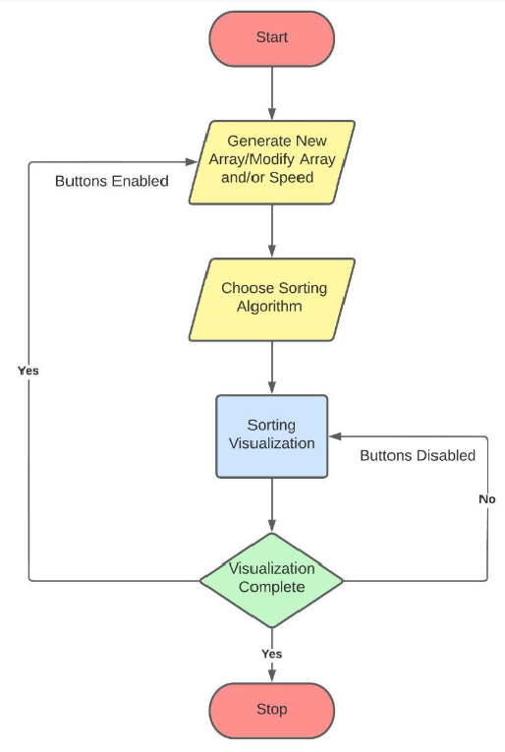

4.2 Architectural Design

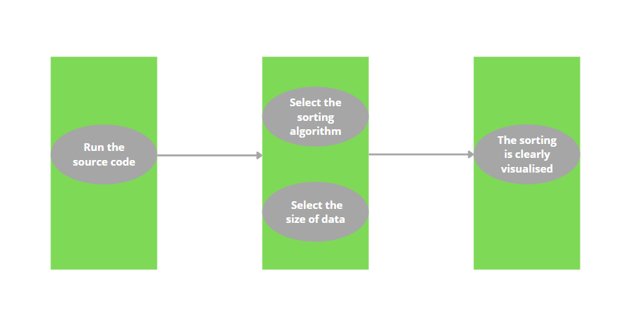

CHAPTER-5

Implementation

5.1 System modules

The project is implemented using HTML, CSS and JavaScript.
There are 6 JavaScript modules in the project:
- bubble.js – to store the bubble sort algorithm and call functions to enable and disable buttons.
- insertion.js – to store the insertion sort algorithm and call functions to enable and disable buttons.
- merge.js – to store the merge sort algorithm and call functions to enable and disable buttons.
- quick.js – to store the quick sort algorithm and call functions to enable and disable buttons.
- selection.js – to store the selection sort algorithm and call functions to enable and disable buttons.
- sorting.js – to define various functions to enable/disable buttons, create new array, delete existing array, adjust array size and sorting speed and select a sorting algorithm.

The html document was designed using bootstrap and CSS.

CHAPTER-6

RESULT

6.1 Outcome

The users can now select any of the given sorting algorithms for its visualization.

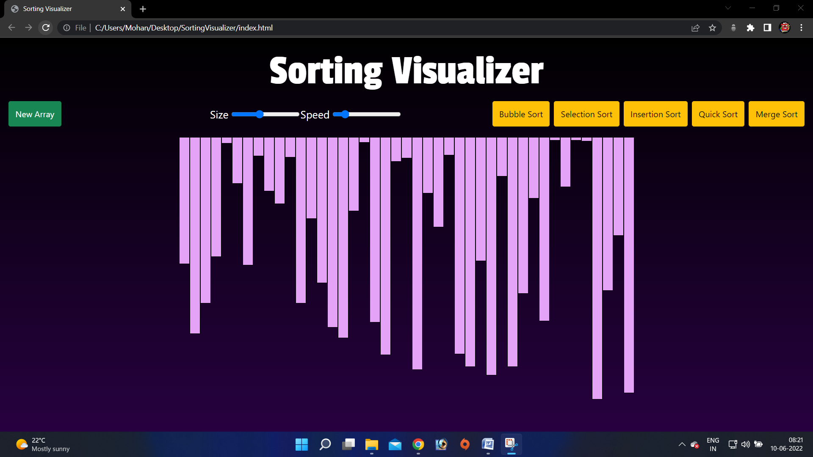

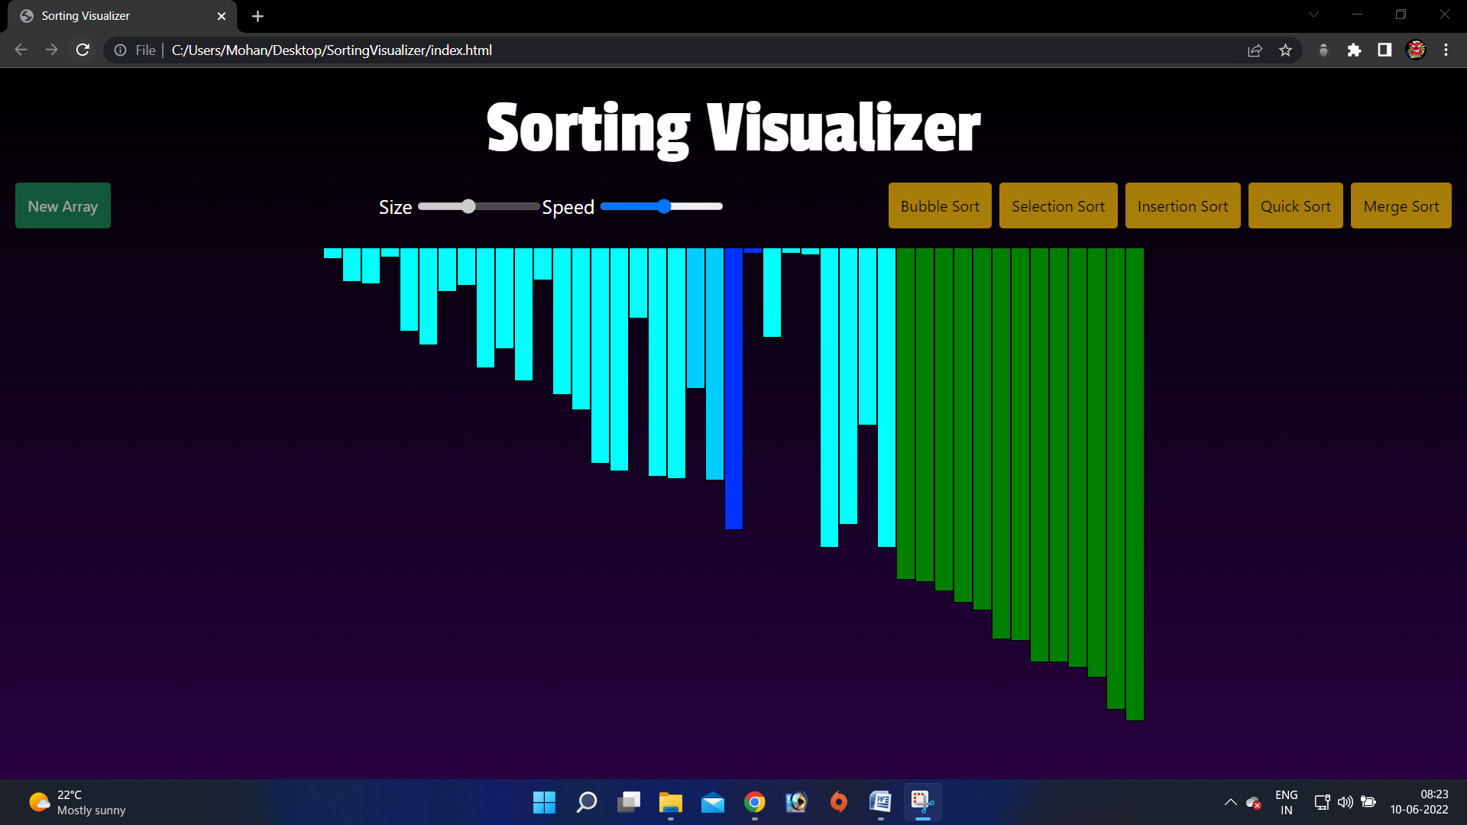

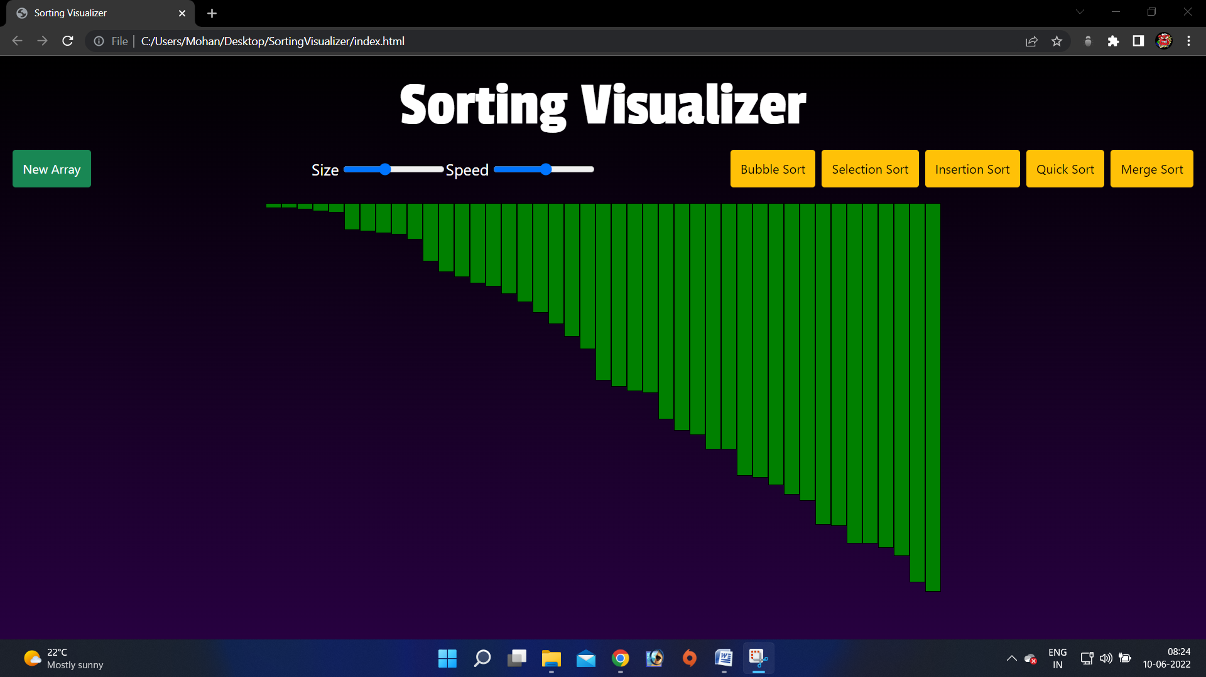

6.2 Conclusion

- The Sorting Visualizer can be used to clearly visualize the working of various sorting algorithms.
- The user can also generate a new array, adjust the size of the array and the sorting speed.

6.3 Future Enhancement

- Visualize more sorting algorithms.
- Creating a game/application utilizing the sorting algorithms.
- Creating a 3D visualization of the same.

References

- Web programming building internet applications by Chris Bates.

